COVID-19 SAFETY PLAN:

PURPOSE:

The purpose of the COVID-19 Safety Plan is to help slow the spread of COVID-19 and reassure employees, contractors, visitors and customers the measures that have been implemented onsite.

Plan to be reviewed to ensure that it is relevant when restrictions and health advise change.
BUSINESS DETAILS
Site Location:
Site Manager Name:

Site Manager Contact:
Plan approved by:
Signature

Consultation with Workers onsite:
Site Safety Contact:
Date Completed

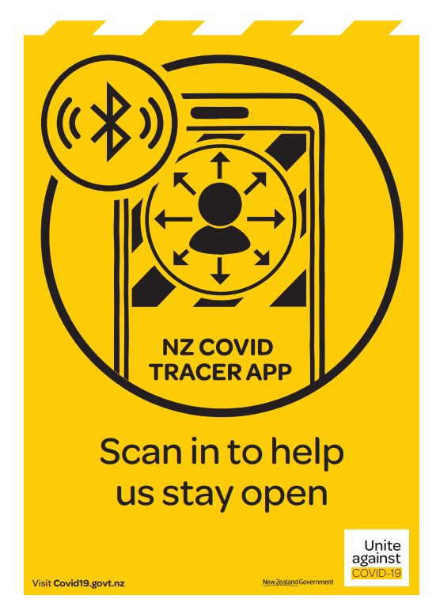

Covid-19 Legislation and  Related Alert Level Response Requirements | COVID-19 Public Health Response Act 2020  http://legislation.govt.nz/act/public/2020/0012/latest/LMS344134.html?src=qs  COVID-19 Public Health Response (Alert Level Requirements) Order 2021  COVID-19 Public Health Response (Alert Level Requirements) Order (No 8) 2021 (LI 2021/165) – New Zealand Legislation
Workplace Controls for  Levels 1 to 4 | Alert Level 1 | Unite against COVID-19 (covid19.govt.nz)

ALERT LEVEL ONE:
Minimum Standards | Actions site has taken
Keep a track of where you’ve been and who you’ve seen | Use the Covid Tracer Tracer app to record QR codes in our workplace, other businesses, shops and public transport
Maintain good hygiene | Good handwashing practices, using soap and water for at least 20 seconds, and drying thoroughly.  Cough and sneeze into your elbow.  Keep surfaces clean.
If you’re feeling unwell | If you have cold, flu or COVID-19 symptoms, stay home.  Call your doctor or Healthline on 0800 358 5453 to see if you need a test. Get a test if you have symptoms
Keep your distance | COVID-19 is contained at Alert Level 1, but it’s still worthwhile to keep a safe distance from people you do not know while out and about.  This will help to minimise the spread of COVID-19 if it reappears in our community.
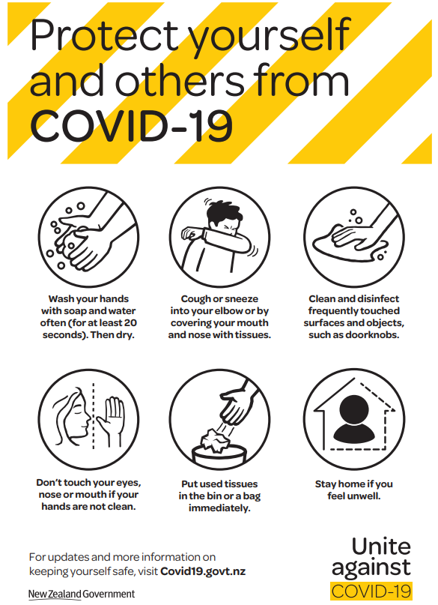
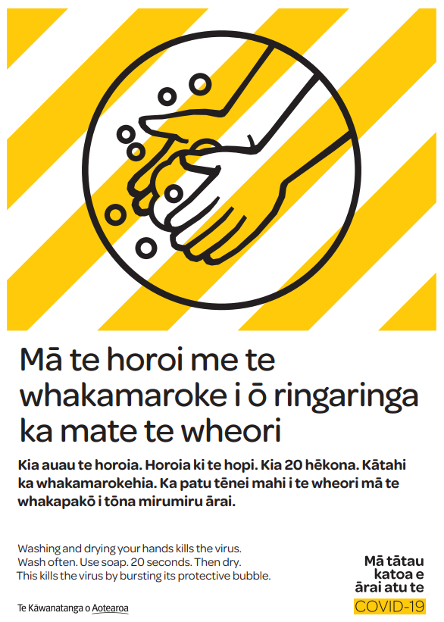

ALERT LEVEL TWO:
Minimum Standards | Actions site has taken
Keep 1 metre distancing between workers.  Keep 2 metres distancing between customers. | All rooms will be signed to instruct on 1 metre separation.  Completed review of tasks and identifying anywhere 1 metre distancing cannot be applied.  Where there is contact with customers face masks are strongly encouraged to be worn.
Where close contact is required | Tasks that don’t allow for 1 metre separation face masks are strongly encouraged to be worn.  Where possible, ensure segregation of work groups onsite.
Businesses are legally required to display a QR code and provide an alternative contact tracing system. | All sites are checked and reported to the GM to ensure compliance
Hygiene requirements | Basic hygiene measures will be legally maintained.  Regular hand washing and surfaces cleaned regularly  Face masks are recommended where appropriate

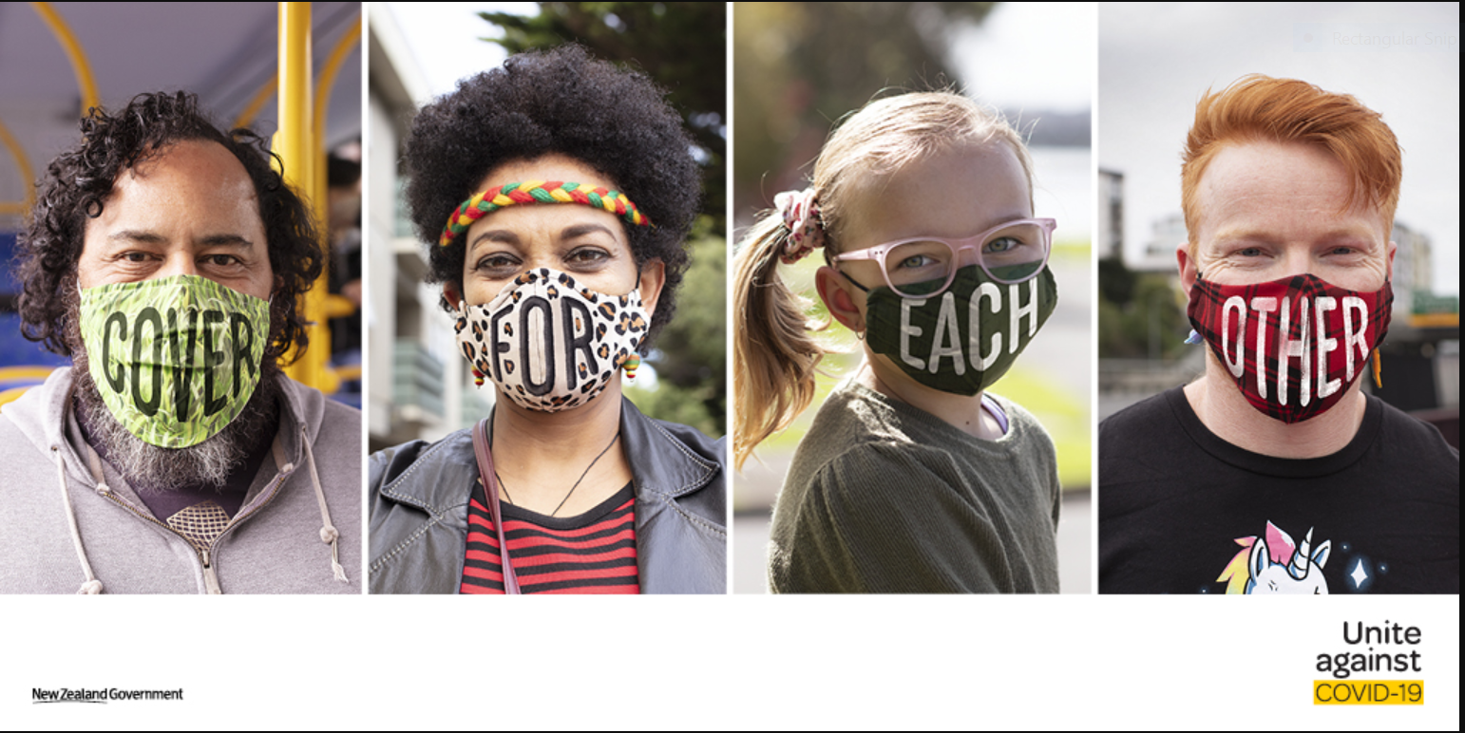

ALERT LEVEL THREE:
Minimum Standards | Actions site has taken
The business must legally be contactless | Customers are allowed/ not allowed to come onsite  Keep 1 metre between staff  Staff encouraged to work from home  Pickup and delivery must be contactless
Travelling in and out of Alert Level Three areas for business.
Travel in and out of Alert Level Three is strictly limited by government.
Hygiene requirements | Basic hygiene measures will be legally maintained.  Regular hand washing and surfaces cleaned regularly  Face masks are recommended where appropriate
If you’re feeling unwell | Workers legally must stay home if they are sick.

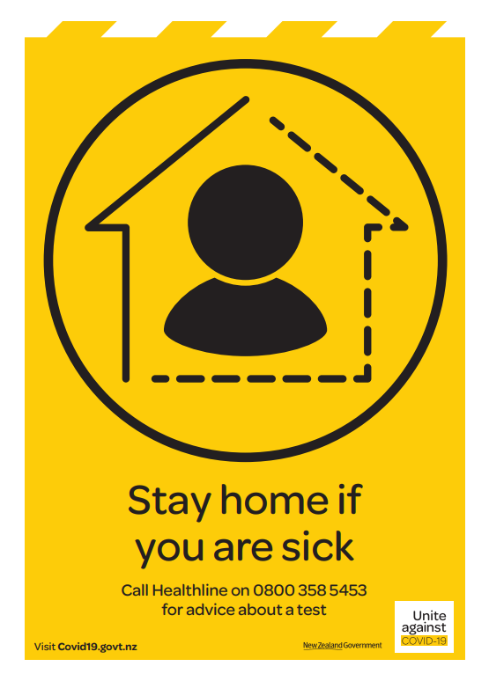
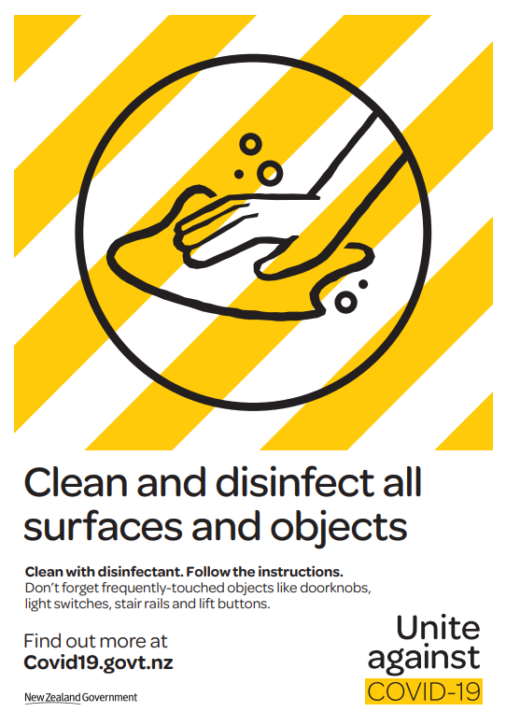

ALERT LEVEL FOUR:
Minimum Standards | Actions site has taken
The business must legally be closed – except essential services. | New Zealand sites will be closed?
People are instructed to stay at home in their bubble
The government will issue information and instructions | Direction will come from …

SITE PROCESSES:
Minimum Standards | Actions site has taken
Ensure 1metre social distancing is maintained at all times | All rooms are signed to instruct on 1m separation.  Complete a review of tasks and identifying anywhere 1m social distancing cannot be applied.  Tasks that don’t allow for 1m separation require face masks to be worn regardless of current government directives.
If possible, ensure segregation of work groups on sites. This includes separate bathrooms, rest rooms and/or lunchrooms for work groups | Communicate segregation to all work groups.  Areas are sign posted for Social Distancing.
Ensure lunch breaks are staggered between shifts to ensure site can meet lunchroom density requirements | Lunch breaks are staggered between staff.  Lunchroom is signed for maximum limit
Have meetings using digital solutions such as teams or via telephone conference | Implement as standard practise where possible.
When face to face meetings are completed ensure density requirements and social distancing is complied with and meeting in large open space to cater for the people in the meeting | Minimal face to face meetings.  Conduct meetings in open air environment while adhering to social distancing.  Maximum number signage adhered to.
If the government prescribes the use of face coverings how do you monitor and implement this at the site
For close contact tasks ensure the following:  - Keep a record for contact tracing of the task, those who are performing the work and time and date of the close contact  - Have sanitisation available and workstations cleaned  - If it’s not possible to utilise a Perspex shield, consider a N95 or P2 no valve | Daily contact tracing implemented on site.  utilised where 1m physical distancing needs to be breached due to maintenance activities
In the scenario that face masks are directed to be used by a health department, will provide face masks to workers
Other site-specific social distancing measures at the site

Health Monitoring and Wellbeing
Minimum Standard | Actions site has taken
All employees, contractors and visitors to complete the COVID-19 declaration | Daily contact tracing implemented on site.
All sites must have a process in place for the Health Declaration:  - Collection  - Reviewed  - Ensure relevant personnel on site are trained to know what action to take in relation to any exceptions reported in these declarations | If Paper Declaration Used –  Filing all paper-based declarations daily record keeping on site for the following month then destroy. i.e. max 60 days & reviewed by Site Manager daily  Staff are trained on handling exceptions to the declaration requirements
Any worker or visitor that has been tested for COVID-19 and is awaiting results must not be at any site and self-isolate until their test results have returned, and they are cleared to come back to work | Implemented and communicated as part of the and New Zealand Government requirements  Workers who are tested are advised to contact their manager and isolate until they receive their results.
Exclude workers and visitors that are unwell from the site | As above  In addition, when required the completion of the Health Declaration form prompts managers to have conversation with their teams, visitors, and contractors if they are or have previously been feeling unwell.  Managers are trained to instruct their teams, visitors and contractors that are currently feeling unwell, to self-isolate and consult for medical advice and testing.
Health, Psychological and Wellbeing awareness and resources available to employees and contractors at the site | Employees reminded of support services availability
Other specific health monitoring and wellbeing measures implemented at the site | Regular check-ins with employees undertaken  COVID-19 Safety Walk completed at least quarterly
Hygiene and Cleaning
Minimum Standard | Actions site has taken
If possible, fit doors with foot openers or chocks to limit touching surfaces
Ensure a full clean and disinfect occurs at least once a day with increased cleaning of touch points | Site Cleaners are engaged to complete additional cleaning of high touch point areas.  Each work area is supplied with cleaning supplies.  Work Areas to be disinfected before and after use.
Ensure hand sanitiser is available at the entrance and exit points of sites
Ensure bathrooms are well stocked with hand wash and paper towel
Have sanitisation units at entrance and sign in points at site including Kronos clocks
Cleaning solutions are provided to clean and disinfect surfaces
Disinfectants are the only suitable cleaning solutions for hard services this includes alcohol in a concentration of at least 70%, chlorine bleach in a concentration of 1000 parts per million, oxygen bleach, or wipes and sprays that contain quaternary ammonium compounds
Individuals or cleaners to clean keyboard, mouse, desk space, phone, photocopier, printer, AR equipment, touch screen, smart boards and other contacted areas before use | Shared surfaces / equipment to be provided with disinfectant supplies.
Ensure that all workstations, forklifts and other equipment are sanitised and cleaned before and after use | Shared surfaces / equipment to be provided with disinfectant supplies.
Ensure workers clean personal property that comes to work such as sunglasses, glasses, mobile phones and tablets with disinfectant
Ensure that is a no shaking policy to limit contact between people
Other Hygiene and Cleaning measures implemented at the site | Hand sanitising facilities available to employees.  Forensic Cleaner Details:

